Executive Summary

The data science group recommends Big Mountain Resort to increase the ticket price by $4.48 to increase the revenue and profit. Further, the data science group recommends Big Mountain resort to consider adding a run, increasing the vertical drop by 150 feet, and installing an additional chair lift, which can support the ticket price to be further increased by $1.99. The recommendations are based on a ticket price prediction model. This model is built on analysis of the ticket price data and key features of more than 300 ski resorts in the US. Model uncertainty is considered into the recommendation of $4.48 ticket price increase.

Background & Justification

Earlier this year, the data science group got the task of revisiting Big Mountain Resort’s pricing strategy to capitalize on its facilities as much as it could. Big Mountain Resort is a ski resort located in Montana with about 350,000 people ski or snowboard every year and its current pricing strategy is to charge a premium above the average price of resorts in its market segment. Our group analyses data from more than 300 ski resorts to build a machine learning model. We suggest increasing the ticket price by $4.48, and a further $1.99 if we can invest on adding a run, increasing the vertical drop by 150 feet, and installing an additional chair lift. The data science group tests several models, and the random forest regression model is selected. The key factors that influence the ticket price include but are not limited to:
- vertical_drop
- Snow Making_ac
- total_chairs
- fastQuads
- Runs
- LongestRun_mi
- trams
- SkiableTerrain_ac
Analysis show that Big Mountain Resort has done a good job in investing on these key factors. While the ticket price is only modestly above the average, Big Mountain Resort is top tier on these key factors affecting the ticket price. Some examples showing Big Mountain Resort’s leading role in facilities are listed below.

This model has an expected mean absolute error of $10.39 and this is taken into consideration for the recommendation. Big Mountain Resort’s current ticket price is $81.00, the model-predicted price is $95.87. The recommended increase is $4.48 = $95.87 - $81.00 - $10.39. The new ticket price after increase will be $85.48.

This model is also used for testing different investing scenarios and how it may change the ticket price. We recommend the scenario of adding a run, increasing the vertical drop by 150 feet, and installing an additional chair lift, which can support the ticket price to be further increased by $1.99.
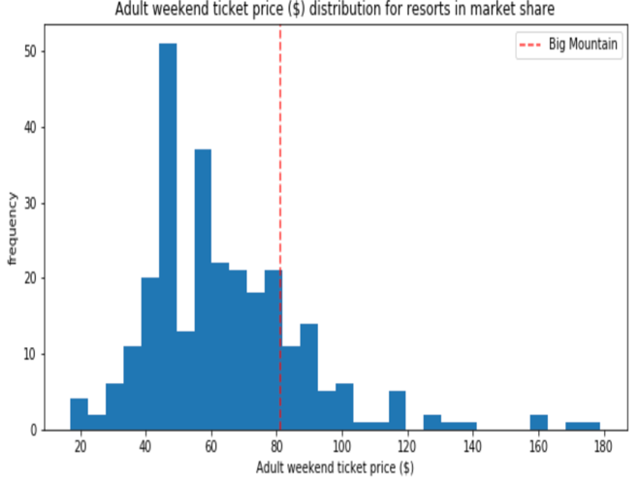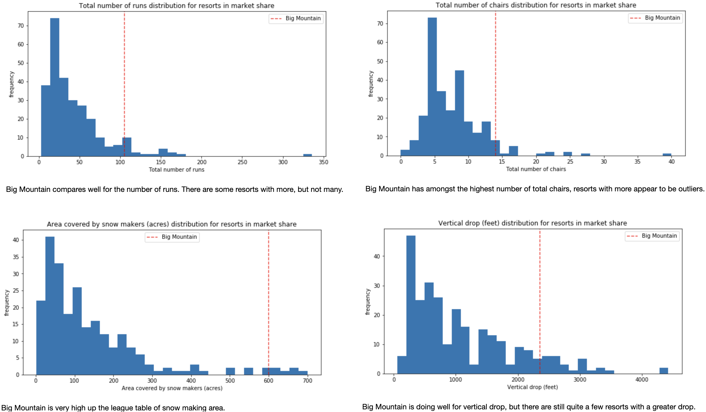
Figure: Ticket price and four key features for all the resorts analyzed. The red dashed line represent Big Mountain.

